STMA WOMEN OF TODAY NEWSLETTER
MARCH 2017

STMA WT members-
Welcome new members Barbara & Joanna! We are so happy you decided to join after participating in events and meeting the last couple months! Great to have you as part of the chapter, officially!
Thank you to everyone who was a part of the Spring craft show. A great big project that we can put a check mark next to for the year. ✔︎
Those we didn’t see at the craft show or we haven’t seen at a meeting, social or project - WE NEED YOU…..
We need volunteers for lots of events/positions- we have 34 members on our roster and would like to see everyone be a part of this great volunteer organization that you joined.
Together we can do many great things and we need everyone to be a part of the together part of our chapter.
Please join us at the April meeting to help us fill the board for next year, take an LPM position, chair a project or sign up to help at an event, chair a social or Membership event.
WE NEED YOU, WE NEED YOU, WE NEED YOU, WE NEED YOU, WE NEED YOU, WE NEED YOU, WE NEED YOU
Without the help of each of us we will not be able to accomplish the great things we have done in our community if we can’t continue to get our members to volunteer!
If you have questions, thoughts, ideas- please contact me, Candi and I will be happy to help you in any way I can.
Please join us for:
The Year-end Banquet
April 25 at 6:30pm
Liberty Bar & Grill, St. Michael
You can enjoy $10 for your meal from the chapter
Let’s celebrate all of our accomplishments for the year!
Please read the meeting minutes to catch up on the news from the March meeting.
Candi ✰
St. Michael-Albertville
Women of Today
General Meeting Minutes
March 14, 2017

Call to Order – 7:03 pm
Pledge of Allegiance – Candi
Orders of the Day/Establish Quorum – Bobbi
- Quorum was established with 14 members present: Abbi Baker, Julie Davis Bobbi Fehrmann, Kris Goodin, Carol Gore, Lori Goutermont, Lisa Haines, Kathy Hansen, Susie Lish, Pauline Meyer, Michelle Skrypec, Candi Testa, Nancy Thompson, and Patti Weber.
- Guests: Barb Benolkin and Joanna Bolduc.

OLD BUSINESS/RECAPS

OFFICERS REPORTS – NEW BUSINESS

Past President/Parli. – Bobbi
- District Director – Kathy Hansen
- 2017-2018 Board Positions. Discussion ensued regarding we need to fill our board member positions for the new year May 1, 2017 through April 30, 2018. The State recommends we have at least a President, State Delegate, Membership, and Treasurer. Because Kathy Hansen will be our District Director if we do not find someone who would be willing to be State Delegate we would be able to receive up-to-date information from Kathy. It was discussed that we could share responsibility of a board position; for example maybe you don’t like paperwork but you enjoy the networking aspect of a position. Perhaps there are two of you who would like to be co-board members. The same holds true for the LPM positions. There does not need to be one LPM per section. We need to make sure we are providing information at the State level to ensure SUCCESS, that our chapter is thriving and giving back to the community. The board positions for 2017-2018 are:
  - President
  - Programming VP
  - Membership VP – Julie Davis
  - State Delegate
  - Treasurer – Lori Goutermont
  - Secretary – Michelle Skrypec
  - Parliamentarian – Nancy Thompson
A motion was made by Bobbi Fehrmann and seconded by Carol Gore to begin proceedings for the election of the above mentioned board positions. Motion passed.
- Bylaw and policy vote. Motion was made by Bobbi Fehrmann and seconded by Lori Goutermont to approve the revised 2016/2017 Bylaws and Policies as discussed during the February general meeting and distributed 30 days prior to the March meeting. Motion passed.
- Craft Fair Meeting Update – Placed on hold until future meeting.

Secretary – Christine (Carol)
- Minutes for the January general meeting were approved.
- Minutes for the February general meeting were approved.

State Delegate – Kathy/Lisa
- Area 2 meeting is March 31 in Rice, MN. Cost is $8 if you sign up early or $10 at the door. We need a volunteer to sign up to make a hot dish for the meeting. Let Kathy know if you would like to do this and then she will bring it to the meeting.
- District Meeting is March 25 in Mora. Cost is $9.
- Year-end convention is May 19-21 in Bemidji. A signup sheet went around for all three of these meetings. Let Kathy know if you will be attending.
- State President candidate for 2017-2018 is Shelley Struzack from Rice chapter. Information was shared regarding Shelley.
- Visitations – only one other member has participated in a visitation to another chapter besides Kathy. If you have or will be making a visitation please bring a signed sheet to Kathy. There will be a drawing for a nice basket at year end banquet for those members who have participated in a visitation.
- Awards:
  - STMA – Growth +1
  - Health and Wellness 2016-2017 through the National: Abbi Baker, Michelle Skrypec, Julie Davis Bobbi Fehrmann, Lisa Haines, Kathy Hansen Lori Goutermont, and Kathy Kessler

Membership VP – Carol
- Socials – Saturday morning coffee. Bobbi will hold and impromptu social once a month at one of the local coffee shops. This will be on a Saturday morning. The first one was this past Saturday and Bobbi was the only one who attended. Bobbi will update us on the next coffee break for date, time and location. This sounds like a great opportunity to get away on a Saturday morning enjoy a fresh cup of coffee and great conversation.
- M-Events or Socials – let Carol know if you would like to host an M-event or a Social. Each event has up to $75 available (not for alcohol).
- Renewals – There have been seven early bird renewals for the third trimester. Two members will not be renewing.
- Serves You Right – total today was $8.43 and Nicole Talley your name was picked. The $8.43 will carry over to the April general meeting.

Internal & External VP – Abbi
- Community Connections – Julie
Family Night Out:
March – Dan & Meghan Sharpe, child Madilyn; caregiver Kailee Sharpe
Senior Citizen event – need chair
Just Drive program in conjunction with Safe Communities. April 29, 2017. _______ is chairing. Motion was made by Julie Davis and seconded by Lori Goutermont that we take $250 from external miscellaneous for Just Drive Day event. Motion passed.
Track and Field ribbons – Nancy – This will be our last year providing ribbons for the primary and elementary schools. Nancy has notified the principals of each individual school.
Albertville Friendly City Days – need a chair
Highway Cleanup Spring – Bobbi will chair again. This is scheduled for May 18th.
Possible ideas for projects. Who wants to chair?
- Suitcases for foster kids – making it a competition with other local organizations
- Oral health kits for homeless shelter and Open Doors
- Dating violence seminar with Rivers of Hope in Monticello and Central Minnesota Sexual Assault Center as speakers
Newsletter – Michelle – articles due by Friday 3/17, newsletter out by 3/24.
Ways & Means – Lisabet (Candi)
- Motion was made by Julie Davis and seconded by Pauline Meyer to no longer hold the Spring Craft Fair that is currently held in March at Middle School West. Motion passed.
- 2017 Spring Craft Fair set up is 3/17 and the day of the craft show is 3/18. Volunteers are still needed.
- Coborn’s Dairy Day June 6 – chair needed.

Treasurer – Pauline
- Financial report: Checking $7,204.97. Savings $15,077.40. A breakdown of the Fall 2016 Craft Fair Expense Report was also shared. The end net profit was $17,123.79.
- Donation/Motion Requests:
  - M/S/P Pauline Meyer, Lori Goutermont to take $67 from internal miscellaneous to cover Kathy Hansen of executive councils district director for 3rd trimester 2016/2017.
  - M/S/D Pauline Meyer, Lori Goutermont to take $250 from external miscellaneous to donate to Alexandra House. The Alexandra House is located in Blaine and a women’s shelter has just opened in the Wright County. After discussion it was decided to donate to the shelter in Wright County.
  - M/S/P Pauline Meyer, Kris Goodin to take $250 from external miscellaneous to donate to the STMA Girls Fast pitch association.
  - M/S/P Pauline Meyer, Julie Davis to take $250 from external miscellaneous to donate to the STMA Youth Baseball.
  - M/S/P Lisabet Thomas, Patti Weber to take $250 from external miscellaneous to donate towards “A Night to Remember” special needs prom for students 15-25.
  - M/S/P Pauline Meyer, Carol Gore to take $250 from external miscellaneous to donate to the STMA High School Boys Lacrosse Team.
  - M/S/P Pauline Meyer, Lori Goutermont to take $250 from external miscellaneous to donate to the Victory Riders.

President – Nancy/Candi
- Year End party is April 25th 6:30 pm at Liberty Bar and Restaurant. Please join us for a fun evening.
- Installation – we have two new members Barb Benolkin and Joanna Bolduc. Both were installed at this evenings meeting.

MN Women of Today Creed.

Meeting adjourned at 9:05 pm.

Respectfully Submitted
Carol Gore

Reminder: You can still order logo clothing! See information below.

From:
Cathy Shuman
State Treasurer 2016-17
Just a reminder that the MNWT online store is open from March 10 to April 10 and again from April 26 to May 26. You can order your favorite MNWT logo clothing and purchase it online now! There are 12 items to select from and they come in a variety of sizes and colors. You can also try on samples if you attend area meetings, LOTS, and annual convention. Don't miss this great opportunity! Click here to go to MNWT homepage and scroll down to the store: http://www.mnwt.org/.

Best Wishes to our new Board
During the March meeting, we elected
Julie Davis as Membership Vice President
Lori Goutermont as Treasurer
Michelle Skrypec as Secretary
Nancy Thompson as Past President/Parliamentarian
Open positions still include:
President
Programming Vice President
State Delegate

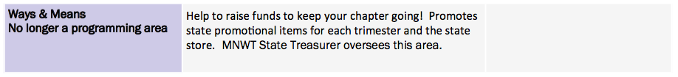
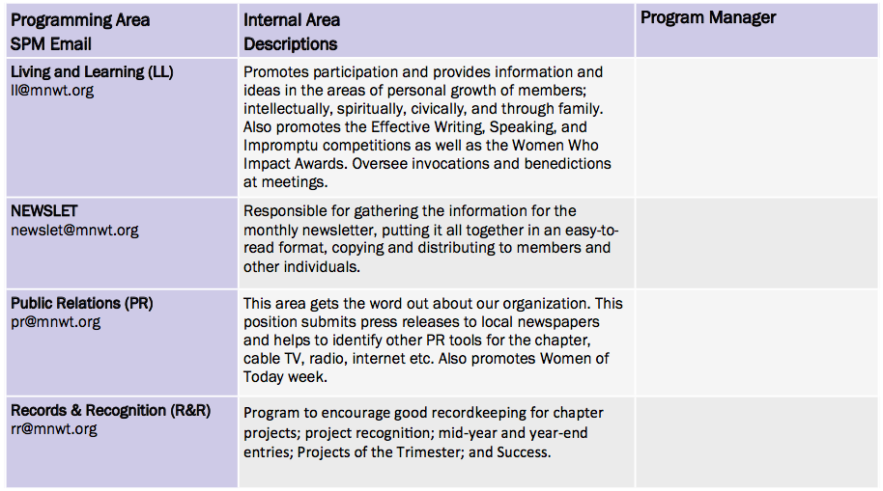
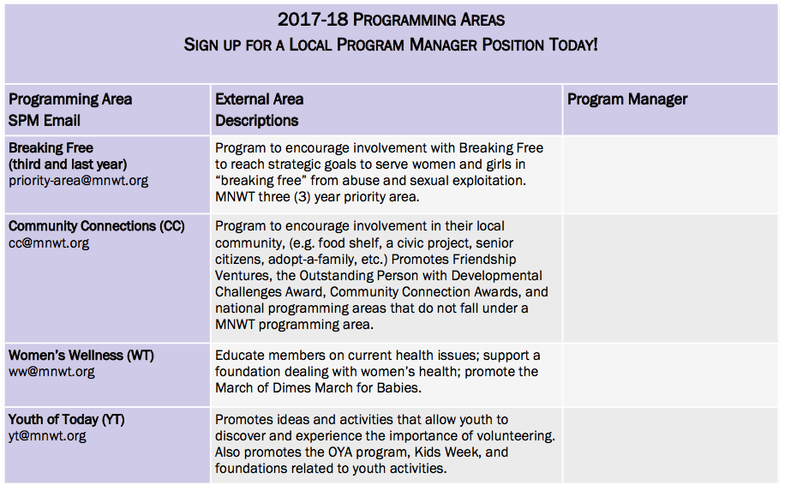
Happy Spring from Women’s Wellness and Living and Learning!
We are still looking for more Personal Development and Living and Learning Certification forms for this trimester. Here are the links to the forms:
http://mnwt.org/bof/forms_results.php?formsID=340
http://mnwt.org/bof/forms_results.php?formsID=311

Please complete and bring to the April general meeting to be included in our last trimester drawing! Thank you-Lori & Kathy K.

Go-Green Pop-Up Recycle Bin Fundraiser
New this year! Recycle your cans and plastic bottles at convention! Help us to purchase the recycle bins needed to do this and to have more shredding events by purchasing your own recycle bins! Pre-order here to ensure that we have enough recycle bins for delivery at any of the Area Meetings and at Annual Convention in Bemidji!
$6 each - Flings Pop-Up Home Recycle Bins
Tall Kitchen Size, 13 Gallon Capacity - Extra Strong - Leak Proof - Universal recycling symbol design for easy identification - Each bin holds 60 cans or bottles - Features a built-in drawstring for easy transporting - Packaged flat and ready to use in a snap - Can be re-used after transferring recyclables into a larger receptacle.
These will be available for pre-order and purchase through Annual Convention 2017!
Flings Pop-Up Home Recycle Bins
> I've invited you to fill out the following form:
> Go-Green Pop-Up Recycle Bin Fundraiser
>
> To fill it out, visit:
> https://docs.google.com/forms/d/e/1FAIpQLScLeTUyDXmajrbfrxVPqR5RWMGX3Qq7sIhID69jBQPaHjyb5w/viewform?c=0&w=1&usp=mail_form_link

Saturday Morning Coffee Party
Two more opportunities this spring to get
together for coffee and good conversation

When: April 1, 2017 (no joke)
Where: Caribou
Time: 9:00 am

When: April 22, 2017
Where: Dunn Brothers
Time: 9:00 am

Highway Clean-up
May 18, 2017
6:00 pm

Please let Bobbi know if you can make it.

RECIPE CORNER

Here is the recipe for the frozen slush we served at the Holiday party. From Lori G.

Golden Punch
1- 46oz can pineapple juice
1- 12oz can frozen lemonade
2- 12oz cans frozen orange juice
5 bananas
2 ½ to 3 cups sugar
6 cups water

Mash bananas in blender and add other ingredients. Freeze until ready to serve. (I use ice cream buckets) Thaw slightly before serving. Scrape with metal spoon and place in glass. Add 7-up or Ginger Ale to make slushy. You can also add rum or vodka to kick it up a notch ;)

Enjoy!
Lori

The STMA Times or “Blueprints”

Thank you Lisa Haines for coordinating the concessions for the Spring Craft Fair – your numbers were spot on – Great Job! - Gretchen

Susie Lish – it was fun working with you and your daughter Elizabeth at the craft fair concessions; you are both quite the speedy walking taco duo! - Gretchen

Carol, Lori G, and Michelle S – You are all math geniuses for working as cashiers at the craft fair concessions; it isn’t easy doing all that nasty math in your head – kudos to you! - Gretchen

Lori G – maybe we should buy you your own plunger so you can unclog the rest of the school sinks – great job on clean up at the craft fair concessions. – Gretchen

Bobbi – Thank you for helping me with picking up all the signs on Saturday after the Craft Fair. It sure helps and goes so much faster with 2 people! Thanks again – Michelle

